Welcome detectives,

As a member of the Historical Crime Scene Investigation, or HCSI, team, you are expected to crack the difficult, unsolved crimes committed throughout history. By using evidence from the scene, previous historical knowledge and expert research and deduction skills, it is your job to piece together the puzzles presented to you.

The latest crime scene is a grizzly one. The evidence is abundant. The specifics are unclear.

Procedure- Send each group member out to the pieces of evidence you need to collect. Then, return to your group and share the information. Next, send one half of your group to other groups to retrieve information missing from your guide sheets. The second half of your group will remain in the original group and brief other groups looking for information.

To conclude, your goals are:

1. Examine the evidence: Use the guide sheet to analyze the evidence presented to you. Note any relevant dates or details you deem important to help you solve the crime.

2. Discuss the evidence with your team members to fully analyze the evidence. Be descriptive and specific. No piece of information can be left unchecked!

3. Retrieve evidence from other groups. Other groups have information that will better help you understand the crime scene. Use their expertise!
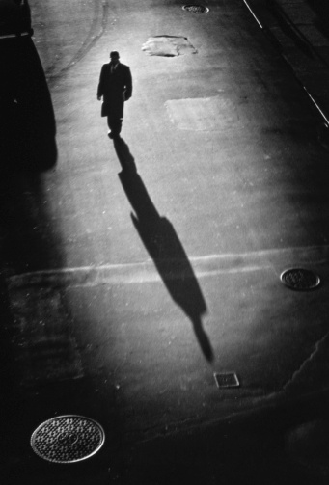
HCSI files

